**Neurology-4plex-V3 테스트용 바코드 (2022.09.28 제작)**

**VEUDx LOT/V1/EZNE22092801/Neurology-4plex-V3/221228/1_a3507.979125_b1.130559_c249929.555076_d38057004.035657/3_a3427.628697_b0.940849_c533837.496638_d39832549.230105/5_a3427.628697_b0.940849_c533837.496638_d39832549.230105/7_a3427.628697_b0.940849_c533837.496638_d39832549.230105**

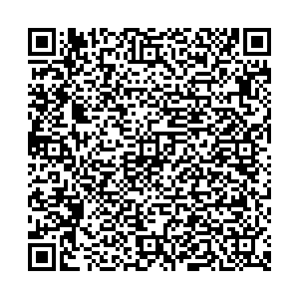

**VEUDx Strip/V1/EZNE22092801/Neurology-4plex-V3/221228**

